
VHDL Code for HUB75 Controller
EECT 6325 VLSI Design

September 4, 2024
university of texas at DAllas

Background
Large outdoor, full color signage installations are often comprised of LED tiles, some of which can be bought on sites like Adafruit, which range from 32x32 to 64x64, with different LED sizes, spacing arrangements, and power requirements. Each one of the pixels has an RGB LED diode. A mux is used to select one or two rows to power; each of the three colors have a dedicated set of serial in, parallel out, shift registers. The Hub75 standard allows for two rows to be addressed simultaneously, so six data pins are used to send that data. A latch, blank and clock pins are used to control the output of those shift registers, and up to five inputs are used to multiplex the rows. Multiple tiles can be chained together, to minimize IO usage. As for clock speeds, timing constraints, and other requirements, they vary between panel manufacturers.
As it stands, if we just set each pixel on or off, then we would only be able to produce 8 colors, black, white, red, green, blue, purple, orange, or teal. To get more colors, we need to add some form of PWM. The easiest way to implement this would be to use a binary coded modulation, or BCM. Each color is represented by 3*n bits of data, with each bit within n controlling how long the RGB LEDs are on or off.

EECT 6325 Project
For this project, I will assume that the shift registers are the TLC59284 with clock and data operating at 20 MHz, and with a mux fast enough to support cycling through all rows 60 times a second. The row x column initially designed is for 16 x 8, with the option to increase or decrease the size based on the cadence complexity. Inputs to this system will be a 24-bit data input, clock @ 200 MHz, and some control lines, with the output being the Hub75 specification, or 6 data lines (r0, g0, b0, r1, g1, b1) clock @ 20 MHz, mux pins A, B, C, latch, and blank. This system works by getting the entire frame data and storing it in 6 RAM blocks, and then reads the MSB of each pixel in that row and storing it in a register. This data is transferred to another register and shifted out onto the pin. After time t0 has passed, the process is repeated with the next set of bits for a duration half the time.
For this first assignment, only the shift register logic has been tested.

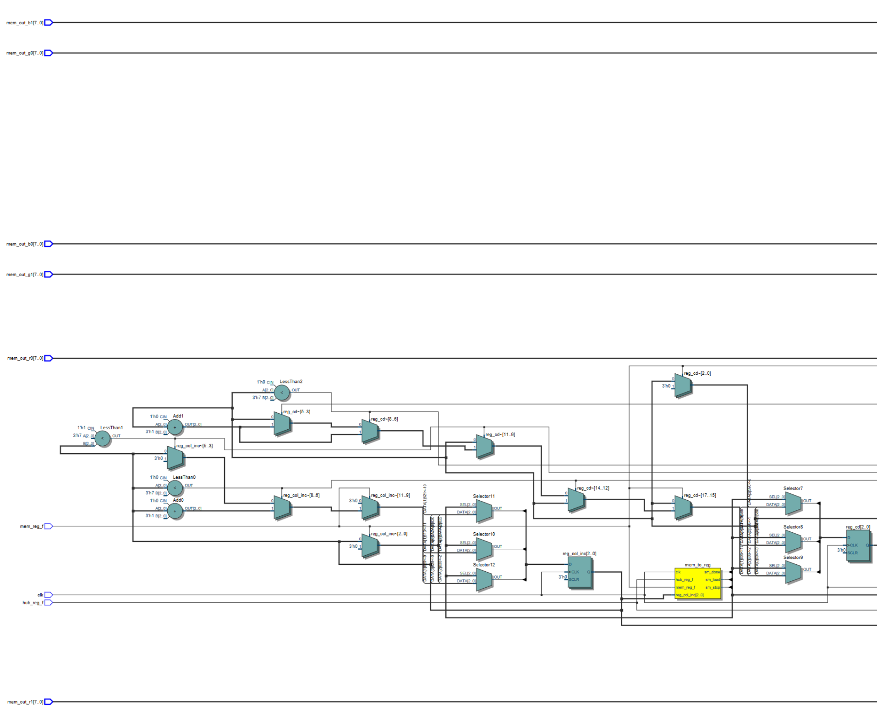
Partial picture, 1/3
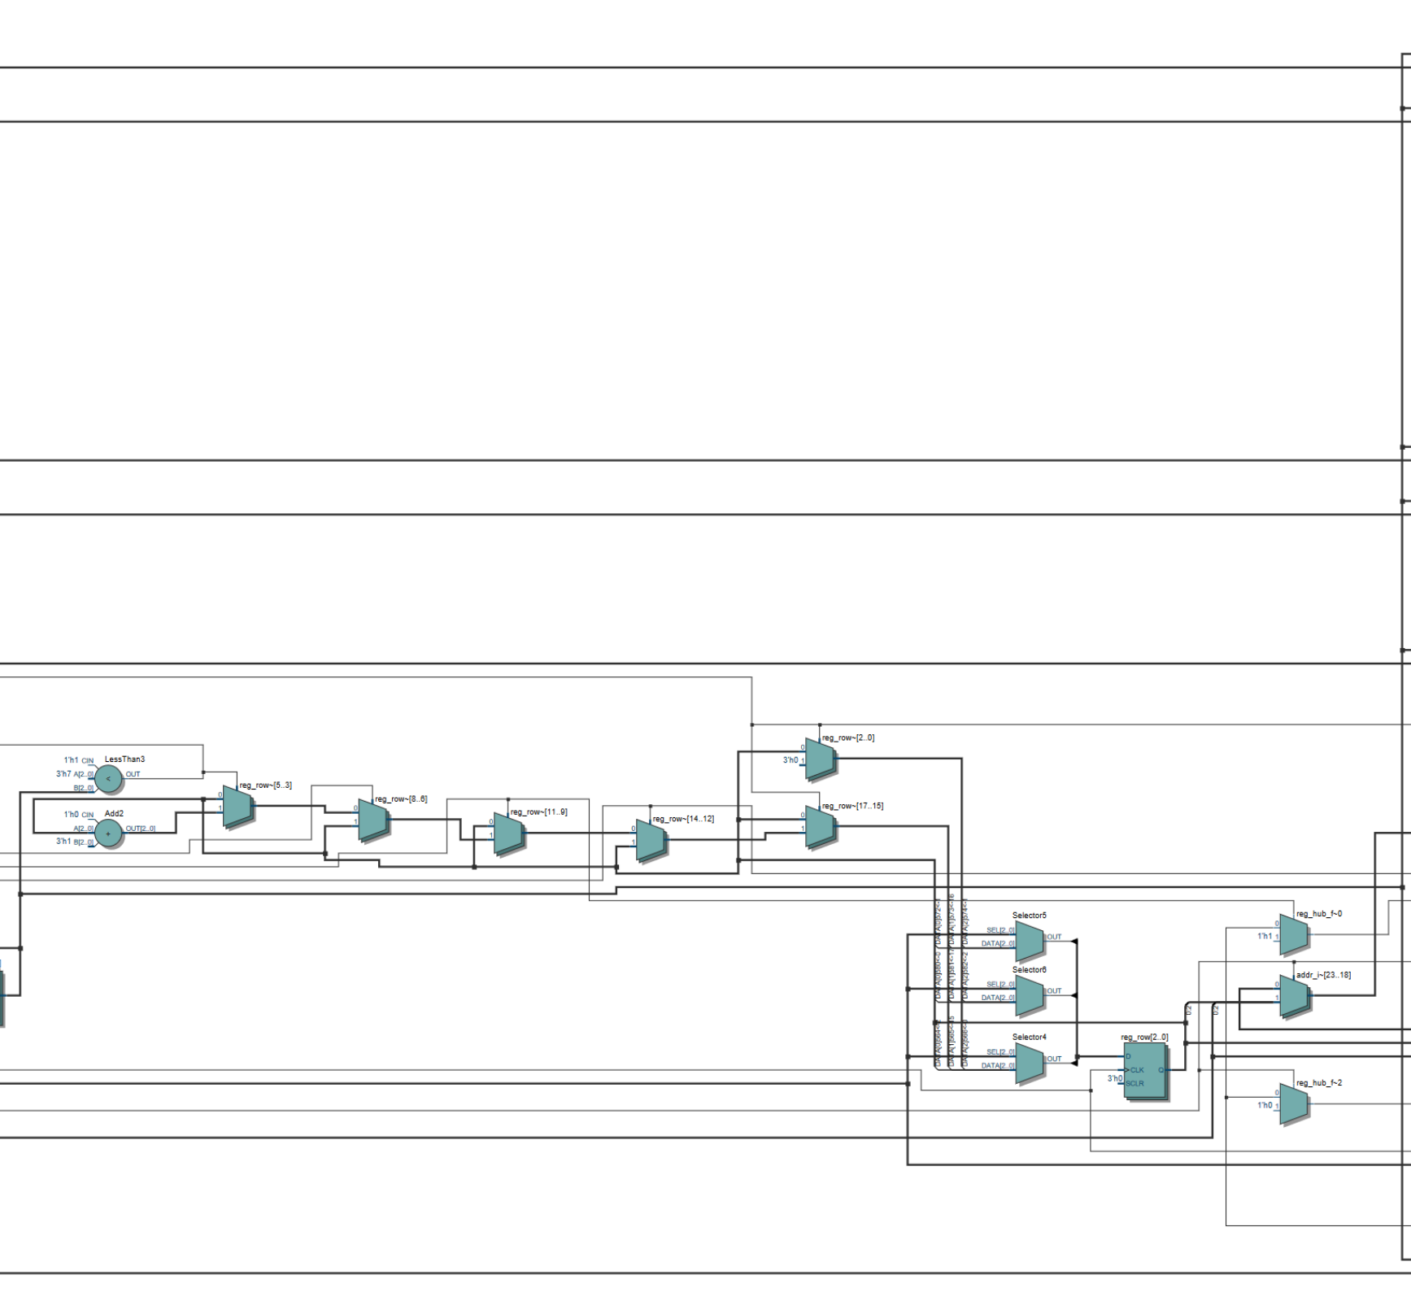
Partial picture 2/3
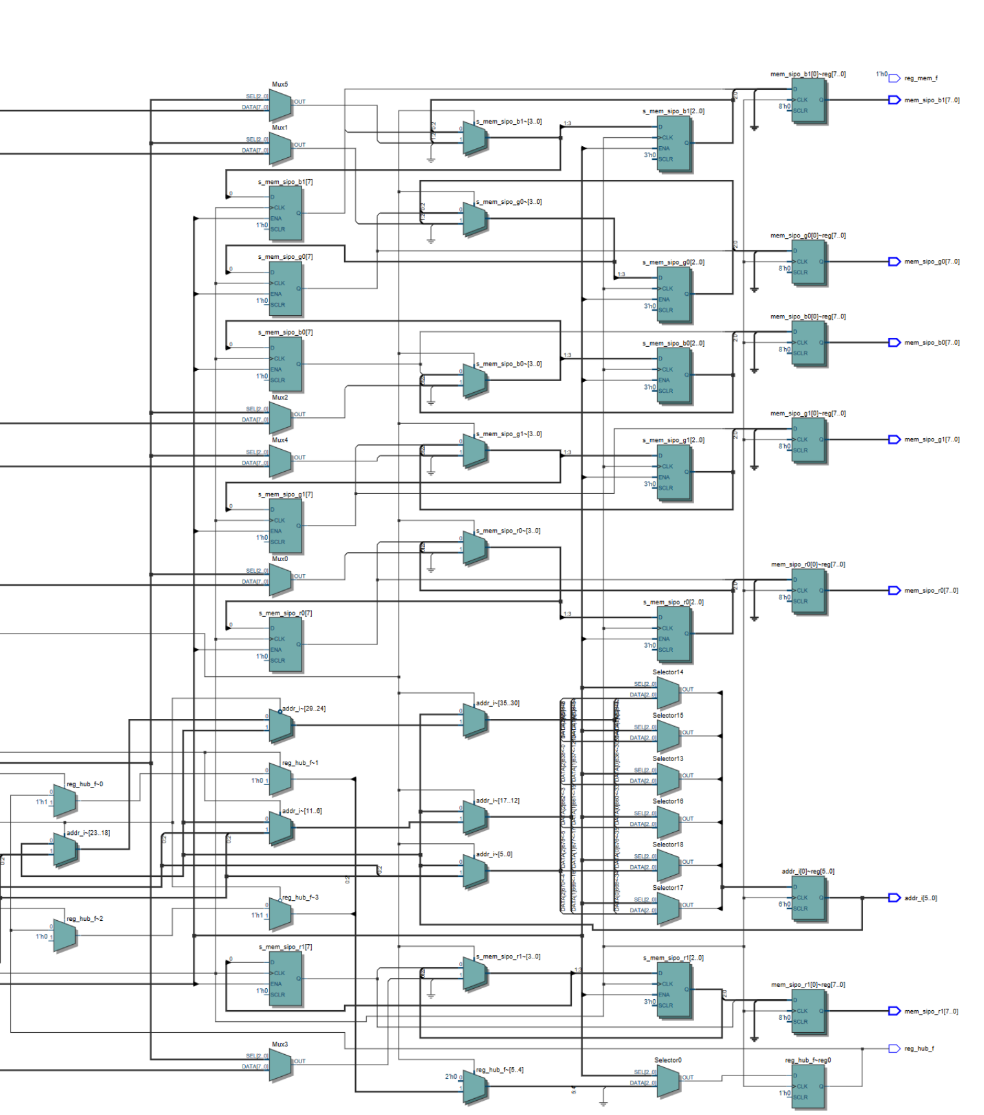
Partial picture 3/3
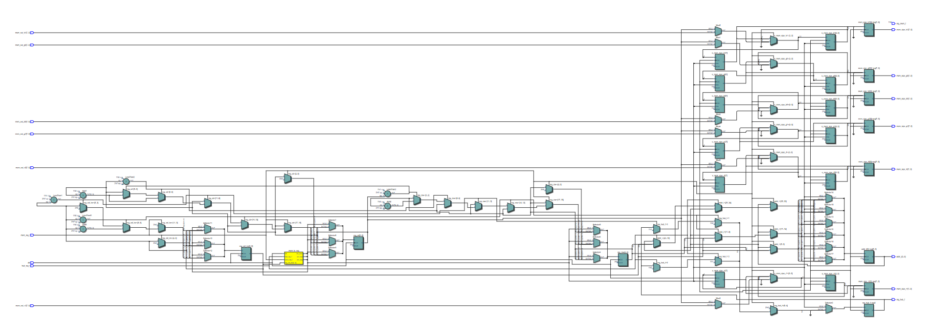
Full picture

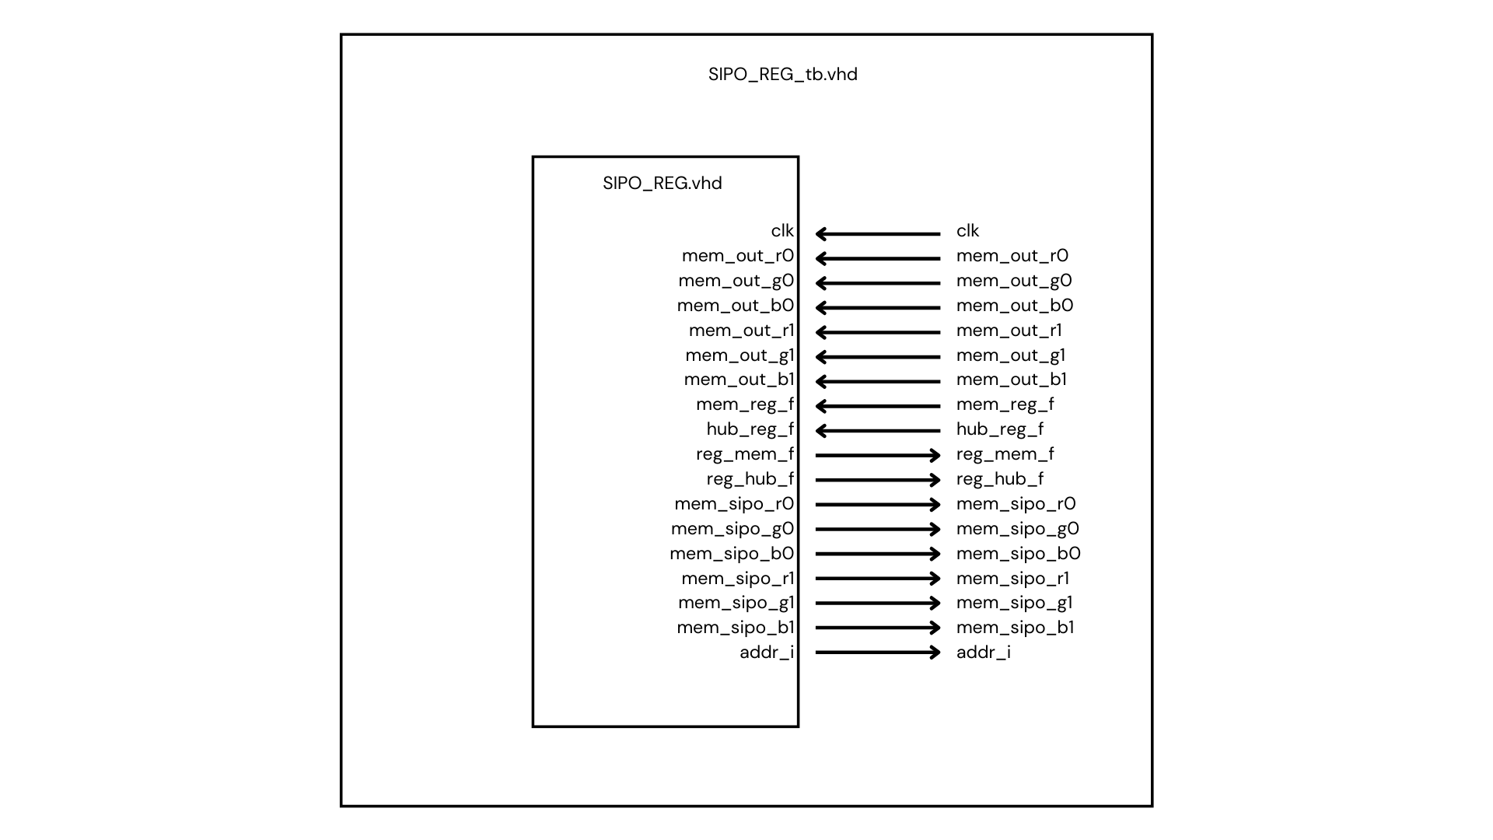
Test bench connections

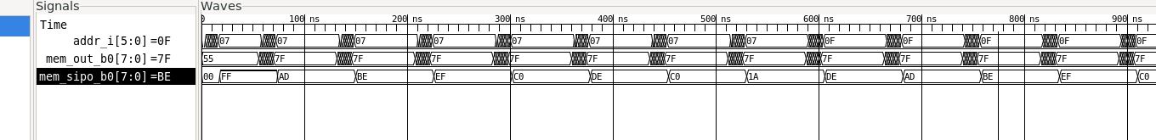
Test bench output. Only one of the 6 outputs tested, but each function the same. The test bench shows “C0DE C01A” and ‘DEAD BEEF” as expected.
The test bench cycles though eight bytes of data, and the UUT constructs the output by reading the nth bit each time. This will be key for using binary coded modulation, as each significant bit will represent varying intensity.

Sipo_reg.vhd:
library ieee;
use ieee.std_logic_1164.all;
use ieee.numeric_std.all;
use ieee.math_real.all;

entity sipo_reg is
generic (
g_color_depth : integer := 8;
g_num_row : integer := 8;
g_num_col : integer := 8
);
port (
clk : in std_logic;
mem_sipo_r0 : out bit_vector(g_color_depth - 1 downto 0);
mem_sipo_g0 : out bit_vector(g_color_depth - 1 downto 0);
mem_sipo_b0 : out bit_vector(g_color_depth - 1 downto 0);
mem_sipo_r1 : out bit_vector(g_color_depth - 1 downto 0);
mem_sipo_g1 : out bit_vector(g_color_depth - 1 downto 0);
mem_sipo_b1 : out bit_vector(g_color_depth - 1 downto 0);
mem_out_r0 : in std_logic_vector(g_color_depth - 1 downto 0);
mem_out_g0 : in std_logic_vector(g_color_depth - 1 downto 0);
mem_out_b0 : in std_logic_vector(g_color_depth - 1 downto 0);
mem_out_r1 : in std_logic_vector(g_color_depth - 1 downto 0);
mem_out_g1 : in std_logic_vector(g_color_depth - 1 downto 0);
mem_out_b1 : in std_logic_vector(g_color_depth - 1 downto 0);
addr_i : out unsigned(6 - 1 downto 0);
reg_hub_f : out bit;
hub_reg_f : in bit;
reg_mem_f : out bit;
mem_reg_f : in bit
);
end entity sipo_reg;

architecture rtl of sipo_reg is

type reg_sm is (sm_stop, sm_load, sm_done);

signal mem_to_reg : reg_sm := sm_stop;

signal reg_col_inc : integer range 0 to g_num_col - 1;
signal reg_row : integer range 0 to g_num_row - 1;
signal reg_cd : integer range 0 to g_color_depth - 1;
signal s_mem_sipo_r0 : bit_vector(g_color_depth - 1 downto 0);
signal s_mem_sipo_g0 : bit_vector(g_color_depth - 1 downto 0);
signal s_mem_sipo_b0 : bit_vector(g_color_depth - 1 downto 0);
signal s_mem_sipo_r1 : bit_vector(g_color_depth - 1 downto 0);
signal s_mem_sipo_g1 : bit_vector(g_color_depth - 1 downto 0);
signal s_mem_sipo_b1 : bit_vector(g_color_depth - 1 downto 0);
signal s_delay : unsigned(1 downto 0);

begin

reg_loader : process (clk) is
begin

if rising_edge(clk) then

case mem_to_reg is

when sm_stop =>

reg_hub_f <= '0';
if (mem_reg_f = '1') then
mem_to_reg <= sm_load;
reg_row <= 0;
reg_cd <= 0;
reg_col_inc <= 0;
addr_i <= (others => '0');
addr_i <= to_unsigned(reg_row, 3) & to_unsigned(reg_col_inc, 3);
elsif (mem_reg_f <= '0') then
mem_to_reg <= sm_stop;
end if;

when sm_load =>

if (mem_reg_f = '1') then
for i in g_color_depth - 2 downto 0 loop
s_mem_sipo_r0(i) <= s_mem_sipo_r0(i + 1);
s_mem_sipo_g0(i) <= s_mem_sipo_g0(i + 1);
s_mem_sipo_b0(i) <= s_mem_sipo_b0(i + 1);
s_mem_sipo_r1(i) <= s_mem_sipo_r1(i + 1);
s_mem_sipo_g1(i) <= s_mem_sipo_g1(i + 1);
s_mem_sipo_b1(i) <= s_mem_sipo_b1(i + 1);
end loop;

s_mem_sipo_r0(7) <= to_bit(mem_out_r0(reg_cd));
s_mem_sipo_g0(7) <= to_bit(mem_out_g0(reg_cd));
s_mem_sipo_b0(7) <= to_bit(mem_out_b0(reg_cd));
s_mem_sipo_r1(7) <= to_bit(mem_out_r1(reg_cd));
s_mem_sipo_g1(7) <= to_bit(mem_out_g1(reg_cd));
s_mem_sipo_b1(7) <= to_bit(mem_out_b1(reg_cd));

addr_i <= to_unsigned(reg_row, 3) & to_unsigned(reg_col_inc, 3);
if (reg_col_inc < g_num_col - 1) then
mem_to_reg <= sm_load;
-- addr_i <= to_unsigned(reg_row, 3) & to_unsigned(reg_col_inc, 3);
reg_hub_f <= '0';
reg_col_inc <= reg_col_inc + 1;
elsif (reg_col_inc >= g_num_col - 1) then
mem_to_reg <= sm_done;
s_delay <= "11";
reg_hub_f <= '0';
reg_col_inc <= 0;
if (reg_cd < g_color_depth - 1) then
reg_cd <= reg_cd + 1;
elsif (reg_cd >= g_color_depth - 1) then
reg_cd <= 0;
if (reg_row < g_num_row - 1) then
reg_row <= reg_row + 1;
elsif (reg_row >= g_num_row - 1) then
reg_row <= 0;
end if;
end if;
end if;
elsif (mem_reg_f = '0') then
mem_to_reg <= sm_stop;
reg_hub_f <= '0';
reg_col_inc <= 0;
end if;

when sm_done =>

mem_sipo_r0 <= s_mem_sipo_r0;
mem_sipo_g0 <= s_mem_sipo_g0;
mem_sipo_b0 <= s_mem_sipo_b0;
mem_sipo_r1 <= s_mem_sipo_r1;
mem_sipo_g1 <= s_mem_sipo_g1;
mem_sipo_b1 <= s_mem_sipo_b1;
if (s_delay = "00") then
if (mem_reg_f = '1') then
if (hub_reg_f = '0') then
mem_to_reg <= sm_done;
reg_hub_f <= '1';
elsif (hub_reg_f = '1') then
mem_to_reg <= sm_load;
-- addr_i <= to_unsigned(reg_row, 3) & to_unsigned(reg_col_inc, 3);
reg_hub_f <= '0';
end if;
elsif (mem_reg_f = '0') then
mem_to_reg <= sm_stop;
reg_hub_f <= '0';
end if;
else
s_delay <= s_delay - 1;
reg_hub_f <= '1';
end if;

when others =>

null;

end case;

end if;

end process reg_loader;

end architecture rtl;

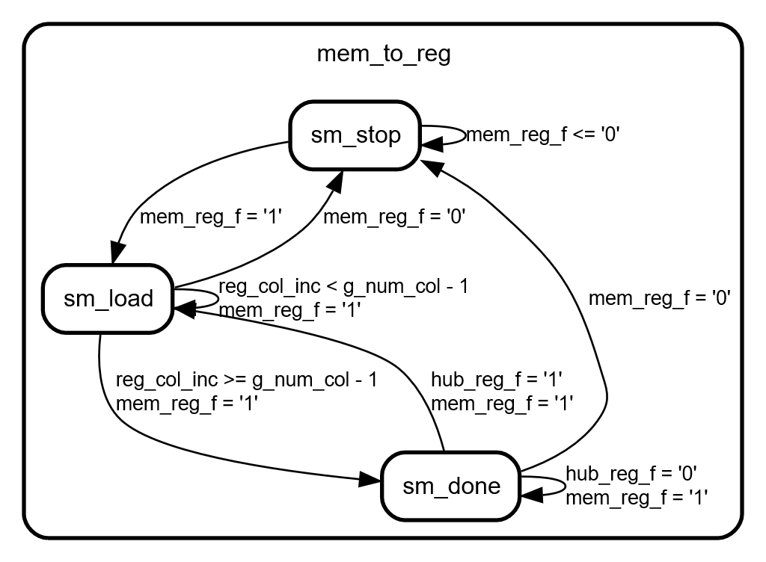

Sipo_reg_tb.vhd:
library ieee;
use ieee.std_logic_1164.all;
use ieee.numeric_std.all;

entity sipo_reg_tb is
end;

architecture bench of sipo_reg_tb is
-- Clock period
constant clk_period : time := 1 ns;
-- Generics
constant g_color_depth : integer := 8;
constant g_num_row : integer := 8;
constant g_num_col : integer := 8;
-- Ports
signal clk : std_logic := '0';
signal mem_sipo_r0 : bit_vector(g_color_depth - 1 downto 0);
signal mem_sipo_g0 : bit_vector(g_color_depth - 1 downto 0);
signal mem_sipo_b0 : bit_vector(g_color_depth - 1 downto 0);
signal mem_sipo_r1 : bit_vector(g_color_depth - 1 downto 0);
signal mem_sipo_g1 : bit_vector(g_color_depth - 1 downto 0);
signal mem_sipo_b1 : bit_vector(g_color_depth - 1 downto 0);
signal mem_out_r0 : std_logic_vector(g_color_depth - 1 downto 0) := X"00";
signal mem_out_g0 : std_logic_vector(g_color_depth - 1 downto 0) := X"55";
signal mem_out_b0 : std_logic_vector(g_color_depth - 1 downto 0) := X"55";
signal mem_out_r1 : std_logic_vector(g_color_depth - 1 downto 0) := X"55";
signal mem_out_g1 : std_logic_vector(g_color_depth - 1 downto 0) := X"55";
signal mem_out_b1 : std_logic_vector(g_color_depth - 1 downto 0) := X"55";
signal addr_i : unsigned(6 - 1 downto 0);
signal reg_hub_f : bit;
signal hub_reg_f : bit := '0';
signal reg_mem_f : bit;
signal mem_reg_f : bit := '0';
signal finished : boolean := false;
begin

sipo_reg_inst : entity work.sipo_reg
generic map (
g_color_depth => g_color_depth,
g_num_row => g_num_row,
g_num_col => g_num_col
)
port map (
clk => clk,
mem_sipo_r0 => mem_sipo_r0,
mem_sipo_g0 => mem_sipo_g0,
mem_sipo_b0 => mem_sipo_b0,
mem_sipo_r1 => mem_sipo_r1,
mem_sipo_g1 => mem_sipo_g1,
mem_sipo_b1 => mem_sipo_b1,
mem_out_r0 => mem_out_r0,
mem_out_g0 => mem_out_g0,
mem_out_b0 => mem_out_b0,
mem_out_r1 => mem_out_r1,
mem_out_g1 => mem_out_g1,
mem_out_b1 => mem_out_b1,
addr_i => addr_i,
reg_hub_f => reg_hub_f,
hub_reg_f => hub_reg_f,
reg_mem_f => reg_mem_f,
mem_reg_f => mem_reg_f
);
-- clk <= not clk after clk_period/2;

process is
begin
clk <= '1';
wait for clk_period;
clk <= '0';
wait for clk_period;
if finished then
wait;
end if;

end process;

process is
begin

mem_reg_f <= '1';
wait for 4 * clk_period;

for a in 0 to 20 loop
for b in 0 to 1 loop

end loop;
wait for 50 * clk_period;
wait for clk_period * 2;
mem_out_b0 <= X"0a";
hub_reg_f <= '1';
wait on addr_i for 4 * clk_period;
hub_reg_f <= '0';

mem_out_b0 <= X"ad";
wait on addr_i for 4 * clk_period;
mem_out_b0 <= X"2f";
wait on addr_i for 4 * clk_period;
mem_out_b0 <= X"af";
wait on addr_i for 4 * clk_period;
mem_out_b0 <= X"a5";
wait on addr_i for 4 * clk_period;
mem_out_b0 <= X"0e";
wait on addr_i for 4 * clk_period;
mem_out_b0 <= X"79";
wait on addr_i for 4 * clk_period;
mem_out_b0 <= X"7f";

wait for 10 * clk_period;

end loop;
finished <= true;
wait;
end process;
end;

